Discussion Boards

The discussion board is where you will likely spend a lot of your time as you discuss a variety of different topics with your instructor and fellow classmates. Interaction is an important component of all online courses, and the discussion board is the most common tool for it.

The discussion board icon looks like two overlapping chat bubbles. Next to it, you will find the forum title and description.

The description explains what will be discussed in the forum and often includes questions, instructions, and expectations. Read this information closely to understand the requirements.

To prevent losing your work due to crashes or outages, a good practice is to type your work in a Microsoft Word document first. Save it to your computer and when ready to post, copy and paste the contents into the forum.

When you are ready to participate in a discussion board, click on the forum title to access it.

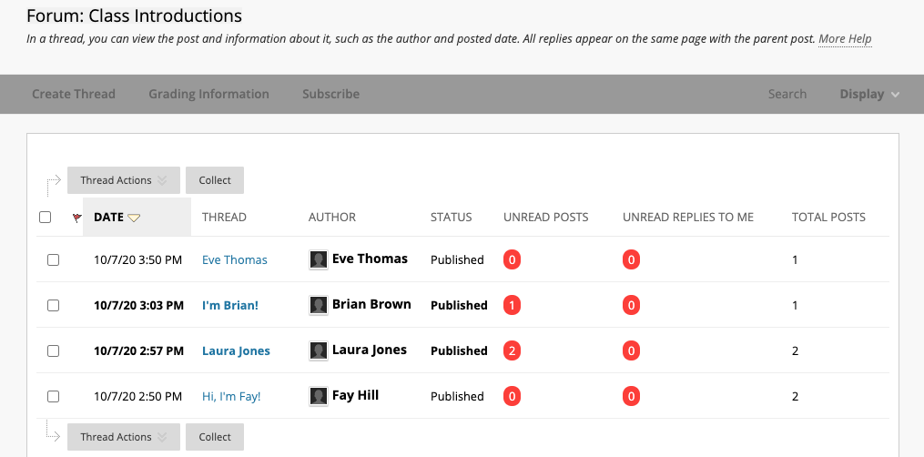

Next, view the document on Reading a Discussion Board.

